**Program 19 : Demonstrate the SQLite database operation create, read, update and delete on a table.**

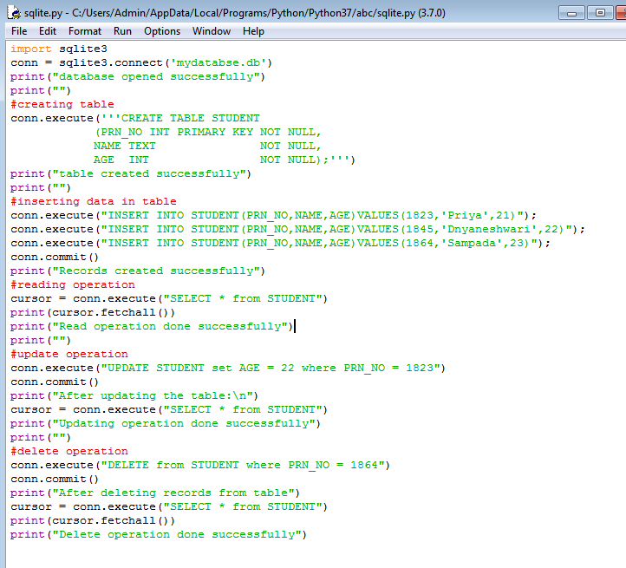

**Output:**

